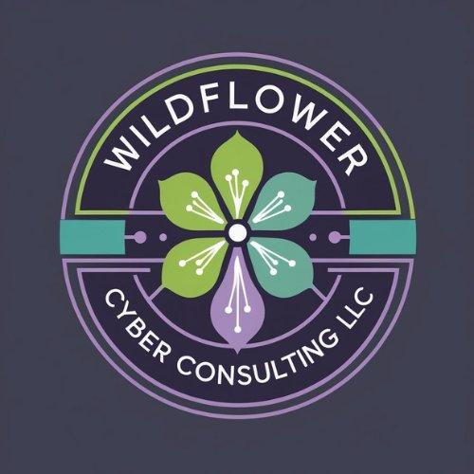  NASREEN BELFON  CISSP · CISM · CRISC | FREE CHECKLIST  AI + Cyber Quick  Audit Checklist  25 questions across 5 areas. Work through them honestly. By the end, you'll know exactly where your security and AI risk exposure is highest.

📋 How to use this checklist
For each question, tick the box if your honest answer is yes. Leave it blank if the answer is no, you're not sure, or it's only partly true. Items marked HIGH RISK are the ones attackers target most often — address those first. Count your checked boxes at the end and use the scoring guide.

1 | Accounts & Access  Who can get into your systems — and how

The majority of data breaches start with a compromised account. These five questions cover the most common ways that happen.

☐ | Multi-factor authentication (MFA) is turned on for your email accounts. HIGH RISK.  Email is the most targeted account in any organization. A stolen password alone should not be enough to get in.

☐ | MFA is turned on for any cloud tools or SaaS apps your team uses to handle client or customer data, HIGH RISK  A single account without MFA is enough. Attackers try every account until one without MFA lets them in.

☐ | When a staff member leaves, their accounts are deactivated on the same day.  Former employees keeping access after departure is one of the most common and most preventable insider risk scenarios.

☐ | Staff use separate passwords for each work account — they are not reusing the same password across multiple tools.  When one service is breached, attackers try those credentials on every other service. Password reuse is how one breach becomes five.

☐ | You know who has administrator-level access to your systems, and that list is shorter than your full staff list.  Administrator access that spreads to everyone because it is convenient is one of the most common configurations attackers look for.

2 | Email & Phishing  Your team's ability to recognize attacks coming through the inbox

Phishing causes over 90% of incidents. These questions cover technical email protections and whether your team knows what to do in response.

☐ | Your staff has received security awareness training in the last 12 months that covered phishing and social engineering, HIGH RISK.  Untrained teams click phishing emails at rates of 25–35%. After a single focused training session, that number drops significantly.

☐ | Your team knows the specific steps to take when they receive a suspicious email — not just 'don't click it' but who to forward it to and how  Recognizing a suspicious email and reporting it quickly is how incidents get contained. Not knowing who to tell means attacks go unreported for days.

☐ | Your email domain has SPF, DKIM, and DMARC records configured  Without these records, anyone can send an email that appears to come from your domain. Your IT provider or domain host can check and configure these.

☐ | For any urgent requests involving money transfers or sensitive data, your team verifies by phone before acting — regardless of how legitimate the email looks.  Business Email Compromise (BEC) attacks impersonate executives or clients and request wire transfers. The defense is a verbal confirmation.

☐ | Your team has been briefed on AI-generated threats — voice calls that sound like someone they know, emails with no spelling errors that ask for unusual actions.  AI voice cloning and AI-generated phishing emails are now common. The old advice to look for spelling errors no longer works.

3 | AI Tools in Your Business  What your team is using — and what data is going into it

Most businesses using AI tools have not reviewed the security implications. These questions establish whether you have visibility and control.

☐ | You have a complete list of all AI tools your team uses for work — including free tools, browser extensions, and AI features built into existing software HIGH RISK.  You cannot govern what you cannot see. Most organizations are also running several AI tools they do not know about.

☐ | Staff know specifically what cannot go into AI tools: client data, customer personal information, passwords, and confidential business information. HIGH RISK.  Without written guidance, staff make individual judgments that are often wrong. Client data in a public AI tool may be stored and used to train the provider's model.

☐ | For any AI tool used to process client or customer data, you have confirmed that your data is not used for model training.  Consumer plans for most AI tools allow the provider to use submitted data to improve the model. Enterprise plans typically prohibit this.

☐ | There is a process for staff to check with management before adopting a new AI tool for work purposes.  Without a clear process, new AI tools get adopted by individuals without any security or legal review.

☐ | If your organization is subject to GDPR, HIPAA, or SOC 2, you have confirmed that your AI tool usage is consistent with those requirements.  GDPR requires a documented lawful basis for any personal data processing — including processing by third-party AI tools.

4 | Data & Devices  Where your information lives and whether it is protected

Lost laptops and unsecured data are among the most common incidents for small businesses. These questions cover the basics.

☐ | Work laptops have full-disk encryption enabled (BitLocker on Windows, FileVault on Mac). HIGH RISK.  A stolen laptop with no disk encryption gives anyone who finds it immediate access to everything on it. With encryption, it is a hardware loss, not a data breach.

☐ | Your business data is backed up, and you have tested restoring from the backup in the last 6 months.  Backups that have never been tested are a common source of failure after ransomware. Knowing your backup works before you need it is critical.

☐ | At least one backup copy is stored somewhere not connected to your main systems — offline, in a separate cloud account, or with a separate provider.  Ransomware attacks now target backup systems specifically. An isolated copy is not optional — it is the recovery plan.

☐ | Staff lock their computers when stepping away, and screens automatically lock after 10–15 minutes of inactivity.  Physical access to an unlocked device is one of the simplest ways sensitive information can leave an organization.

☐ | Your operating systems and software receive security updates — devices are not running end-of-life software with no patches available.  Unpatched systems are the most common target in automated attacks. Many major incidents exploit vulnerabilities that have had patches available for months.

5 | Incident Readiness  What happens when something goes wrong

Most organizations do not think about incident response until they need it. These questions establish whether you have the basics in place.

☐ | Your team knows who to contact — and has a working phone number for them — if they suspect a security incident outside of business hours.  An incident that starts Friday evening and goes unreported until Monday morning has 60 hours to spread. An after-hours contact is not a luxury.

☐ | Your organization has a documented — even simple — incident response procedure that staff are aware of  When something goes wrong, it's the worst time to figure out who does what. Attempting to clean up an incident independently often destroys evidence.

☐ | If your organization handles personal data from EU residents, you know that a personal data breach must be reported to your supervisory authority within 72 hours of discovery.  GDPR's 72-hour notification requirement starts from when you become aware of the breach. Missing this deadline compounds the regulatory exposure.

☐ | Staff are comfortable reporting security mistakes — such as clicking a phishing link or accidentally sharing a file with the wrong person — without fear of being blamed.  Organizations where people fear reporting mistakes discover incidents weeks after they happened. A culture that encourages quick reporting is worth more than any technical control.

☐ | You have cyber insurance, or you have deliberately decided not to purchase it, and you understand what that means for incident costs.  Cyber insurance for small businesses typically costs $1,000–$3,000 per year. The average cost of a small business incident without insurance is $25,000–$75,000.

Your Score

TOTAL SCORE  _ _ / 25 | HIGH RISK ITEMS  _ _ / 7 checked | SECTIONS DONE  _ _ / 5

Want a full picture of where you stand?
The Cyber + AI Risk Snapshot takes this further — with a written findings report, a prioritized action list, and a 30-minute debrief. Fixed fee. No ongoing commitment.
Book a free call: wildflowercyberconsulting.com | [email@wildflowercyber.com]

